**FRONTIER SCHOOL**

**2024-2025** **HANDBOOK**



**Frontier School contact information:**

* Phone Number: 306-296-2040; 306-296-2133
* Fax Number: 306-296-2275
* School Email: [frontier_school@chinooksd.ca](mailto:frontier_school@chinooksd.ca)
* School Website: <http://www.chinooksd.ca/school/frontier>
* Facebook: search “Frontier School”

*“A great place to be!”*

Dear Raiders,

Welcome back to the start of another greatly anticipated year of school. The staff and I are thrilled to see each of your smiling faces on the first day back. We hope you enjoyed your summer and you are ready and raring to go on another learning adventure.

This year, gear yourself up to make a difference! Our school focus this year is to embrace the word “RESPONSIBLE.” To us, at Frontier School, RESPONSIBLE stands for:

Respect

Effort

Safe

Positive

Open

Neat

Self

I can

Believe

LEarn

Each month, we will focus on one of the above mentioned aspects. Afterall, school is not only about learning the curriculum. It is also about learning ways to improve yourself, your relationships, and how to be the best version of yourself that you can be.

Throughout the year our SRC will plan many fun events for students to enjoy, the SCC will fuel our bodies and our brains with snacks and activities, and your classroom teachers will provide many unforgettable learning activities. I cannot wait to see how this year plays out, and I absolutely cannot wait to see everyone continue to grow and learn.

Leave the past behind you, dream about a bright future, and focus on seizing today! Let’s make this school year great, one for the books, a year to remember. Are you up for the challenge?

Sincerely,

Ms. Lauren Kos East and Mrs. Brittany Puszkar

Administration

Frontier School

**Philosophy and Motto**

**Mission Statement**

*Educating students to their highest level of academic achievement in a safe, caring, and inclusive environment that builds a foundation for lifelong learning so they can become successful, respectful and valued adults.*

**Frontier School’s Value Statements**

We will value learning for all

We will value the worth of each individual

We will value life long learning

We will value optimal wellness

We will value respect and responsibility

We will value personal excellence

**Frontier School’s Motto**

It’s a great place to be!

**The School Crest and Logo**





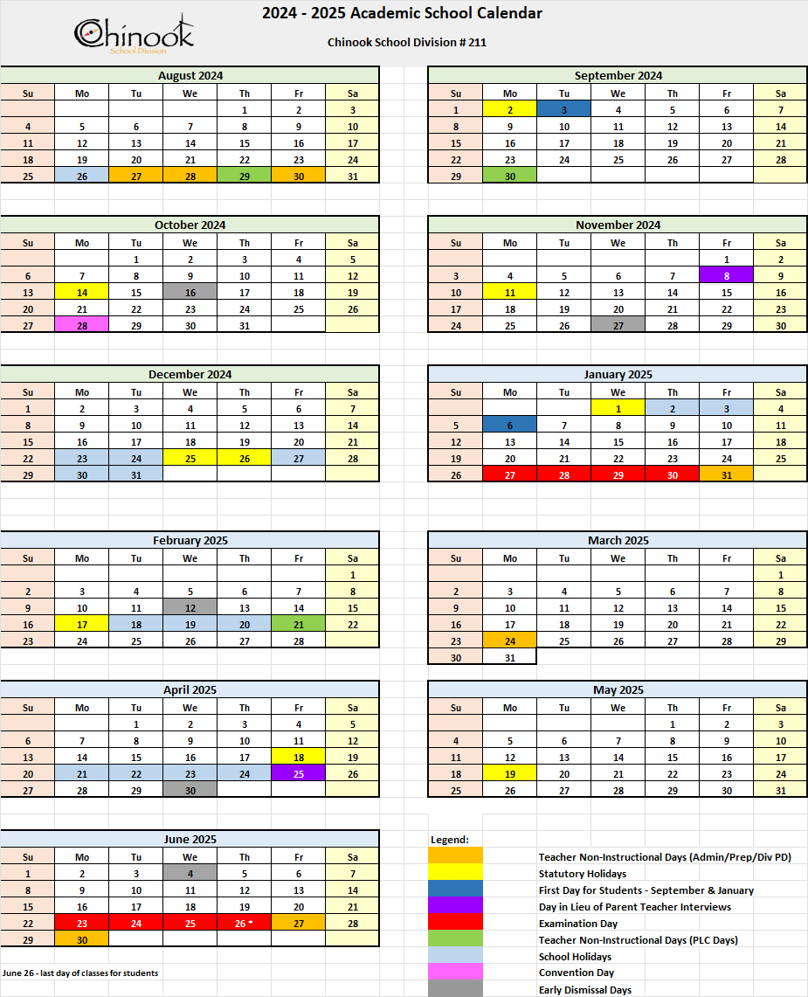

**\*\*early dismissal for students will be at 2:05pm. Busses will be ready to leave the school at 2:10pm and drop students off at their designated locations.\*\***

**Daily Bell Schedule**

**Elementary Bell Schedule - K-5:**

|  |  |  |
| --- | --- | --- |
| 8:40 am |  | Bus Drop Off  Warning Bell |
| 8:45 a.m. - 9:50 a.m. | (60 minutes) | Period 1 |
| 9:50 a.m. - 10:00 a.m. |  | Recess |
| 10:00 a.m. - 11:00 a.m. | (60 minutes) | Period 2 |
| 11:00 a.m. - 12:05 p.m. | (65 minutes) | Period 3 |
| 12:05 p.m. - 12:25 p.m. |  | LUNCH |
| 12:25 p.m. - 12:45 p.m. |  | LUNCH RECESS |
| 12:45 p.m. - 1:50 p.m. | (65 minutes) | Period 4 |
| 1:50 p.m. - 2:00 p.m. |  | Recess |
| 2:00 p.m. - 3:05p.m. | (60 minutes) | Period 5 |
| 3:05 p.m. |  | Dismissal |
| 3:10 p.m. |  | Busses Depart |

**High School Bell Schedule - grade 6-12:**

|  |  |  |
| --- | --- | --- |
| 8:40 a.m. |  | Bus Drop Off  Warning Bell |
| 8:45 a.m. - 9:50 a.m. | (65 minutes) | Period 1 |
| 9:50 a.m. - 10:00 a.m. |  | Break |
| 10:00 a.m. - 11:00 a.m. | (60 minutes) | Period 2 |
| 11:00 a.m. – 11:05 a.m. |  | Break |
| 11:05 a.m. - 12:05 p.m. | (60 minutes) | Period 3 |
| 12:05 p.m. - 12:25 p.m. |  | LUNCH |
| 12:25 p.m. - 12:55 p.m. |  | LUNCH RECESS |
| 12:55 p.m. - 2:00 p.m. | (65 minutes) | Period 4 |
| 2:00 p.m. - 2:05 p.m. |  | Break |
| 2:05 p.m. - 3:05 p.m. | (60 minutes) | Period 5 |
| 3:05 p.m. |  | Dismissal |
| 3:10 p.m. |  | Busses Depart |

***\*\*please note, the warning bell has been removed, students are to go straight to class at 8:45am***

**Frontier School Staff**

Ms. Lauren Kos East Principal

Mrs. Brittany Puszkar Kindergarten/SST/Vice Principal

Mrs. Shantel Balfour Grade 1/2

Miss Cassie Katz Grade 3  
Mrs. Haley Bymoen Grade 4/5

Mr. Ryan Medforth Middle Years General and SST

Mrs. Elizabeth Mariyathas Middle Years and High School Sciences

Mr. Derek Brown Middle Years General

Mr. Norman Sabido Middle Years General and High School

Mrs. Anne Beauchamp Middle Years and High School ELA/History

Mrs. Lori Casat Office Manager

Mrs. Geraldine Ham Librarian

Ms. Mary Mariyathas Educational Assistant

Mrs. Kristi Powlyk Educational Assistant

Ms. Nicole D Educational Assistant

Mrs. Rayann Jarman Educational Assistant

Mrs. Raylee Swarbrick Educational Assistant

Miss Angela Morrow Educational Assistant

Mr. Michael Katz SaskDLC OLF

Ms. Vanessa Varela Facility Operator

Mr. Robert Middleton Custodian

**School Community Council**

The Frontier School Community Council meets on the 1st Monday every second month starting in October at 7:00 pm in the Frontier School.

|  |  |
| --- | --- |
| Geraldine Ham (chair)  Anne Beauchamp (staff rep)  Lauren Kos East (principal)  Myrna-May Samoleski | Kaitlyn Adelia  Kealey Foster  Rayann Jarman  Samantha Miller |

**Student Conduct on the Bus**

[**As Per AP 351**](https://docs.google.com/document/d/1V8rOh9jw_IS2hp4Kn27OkpL_OvqcdMqedoB2BTAXZGU/edit)

The Division requires that student conduct on school buses is consistent with that expected of the student in the classroom. The safety of all students and the driver is of utmost importance while on the school bus.Therefore, it is important that all students follow the school bus rules.

**Bus Drivers**

Nancy Lightfoot: 306-296-7422

Chelsey Carleton: 306-293-2941/306-298-7614

Dennis Klein: 306-293-2819

Wade Carothers: 306-671-7578

**Registration and Fees**

1. Initial registration: upon first entering Frontier School, an electronic registration form will be sent via email to the parent/caregiver. The electronic registration form will request you to provide personal information such as full name, date of birth, parents/guardians, bus drivers, physical address and mailing address. In addition the form will request you to provide medical history, technology consent and parental permissions.
2. Re-Registration: all students re-registering in the fall will be required to complete an electronic registration form to ensure records are up to date.
3. Timetables: student timetables will be devised based on pre-registration forms and will be distributed to students prior to or on the day of the first semester. Changes to student timetables must be arranged in consultation with the administration and parent/guardian.
4. Students will be responsible for the costs of replacing lost or damaged textbooks. Replacing lost locks, repairing damaged or dirty lockers, or repairing damage they cause to school equipment or supplies. Until such costs are paid students will be ineligible to participate in any extracurricular activities.
5. Extracurricular Fees: Students who participate in extracurricular activities involving travel may be charged a fee per activity that must be paid prior to the first away game.
6. The Grade 10-12 students’ fee is $90.00 due September 30th, of the school year-Payable to Frontier School. The fee covers a personalized yearbook and helps cover the additional cost of student activities throughout the school year.
7. Grade 12 graduation fee is $200 due February 1.

**Extracurricular Policy**

1. Participation in any extracurricular activity is a privilege. These activities are an extension of the student’s education; however, academic classes must take precedence. The staff is hopeful that students develop the time management skills to enable them to make a full commitment to all of their classes as well as to extracurricular activities.

1. Expectations of athletes:
   1. attend practices on a regular basis;
   2. exhibit exemplary behaviour at practice, games, in the changerooms, and anywhere else athletes will be;
   3. must be enrolled in classes at or supported by Frontier School;
   4. have all their school fees paid;
   5. **Must assist with setup and cleanup before and after practices, games and tournaments;**
   6. **Must assist with linesing, scorekeeping and foodbooth when other teams are playing**
2. If students fail to follow the expectations outlined in point 2, parents will be informed, and appropriate consequences will then be determined.

1. Possible reason student will not participate in games and tournaments:
2. Fail to uphold student conduct policy
3. Fail to attend practices
4. Fail to be supportive and encouraging to teammates
5. Fail to follow instructions/expectations by coach
6. Students were suspended from school

**Player Fees**

**\*\*Fees must be paid prior to the first practice**

Cross Country: $10.00 Sr. Curling: $30.00  
Sr. Volleyball: $55.00 Jr. Curling: $15.00  
Jr. Volleyball: $45.00 Sr. Badminton: $30.00  
Sr. Basketball: $20.00 Jr. Badminton: $15.00  
Jr. Basketball: $10.00 Track & Field: $30.00  
Golf: $10.00

Without charging a player fee, Frontier School would no longer be able to offer the extensive, excellent sports program that is currently in place.

There will be NO gas mileage reimbursement for Approved Drivers.

**Parent Code of Conduct**

All people involved in Frontier School Activities are responsible for adhering to Frontier School’s Parent Code of Conduct. Some important points:

* I will encourage good sportsmanship by being a positive role model for my athlete as well as others on and off the court.

* I will try my best to make athletics a positive experience for everyone involved. This includes participants, coaches, officials, and spectators.

* I will encourage my players to treat other players, coaches, officials, and fans with respect and dignity. I will not embarrass my child by yelling at other parents, players, coaches, or officials. I will show a positive attitude toward the game and all of its participants.

* As a parent, I will motivate my child to play by the rules. I know that children learn best by example, so I will encourage fair play and applaud outstanding play by either team.

* As a parent, I will help my child learn that success is measured by the development of skills, not winning or losing.

* I recognize the importance of volunteer coaches and others. They are very important to the development of my child and the sport. I will communicate with them, as required, and support them. If I have a concern, I will talk to the coach at the appropriate time and place, ie, never before, during, or immediately after a contest.

**Let’s all show our Raider Pride:**

**BE A FAN NOT A FANATIC!**

If you need further clarification on SHSAA or SWAC Code of Conduct rules we encourage you to go to the SHSAA website and review their Handbook.

It is important for each student to be at school so that they can learn and grown, and we want your child to be at school! See the following information on attendance

[SHSAA Handbook](https://cdn1.sportngin.com/attachments/document/e9fb-2766449/149481_85737_SHSAA_Book_2022_Aug_4_FINAL_PRINT_COMPLETE__002_.pdf#_ga=2.255903759.528944289.1664736287-1953219346.1660878395)

**Classes and Weather**

[**As Per AP 132**](https://docs.google.com/document/d/1C25FvFk2n6bWe8fD8u5ZD_5xkQ1lwYEqABE8tTy6kmk/edit)

Given the geographic size of the Division, providing local discretion in dealing with weather conditions is both prudent and appropriate.

The Director is authorized to dismiss students, discontinue transportation services, cancel classes, and/or close schools in emergency situations.

At Frontier School, the school remains open in all weather conditions and we will strive to do classes as normal.

Notice will be given of bus cancellations as soon as possible.

Please check your email and the Frontier School Facebook page for updates.

**Essential Medication**

This is determined on an individual basis and is governed by  [AP 316](https://docs.google.com/document/d/1V8rOh9jw_IS2hp4Kn27OkpL_OvqcdMqedoB2BTAXZGU/edit)

Teachers and support staff will not administer non-essential medication to students.

**Attendance**

[**As Per AP 330**](https://docs.google.com/document/d/1V8rOh9jw_IS2hp4Kn27OkpL_OvqcdMqedoB2BTAXZGU/view)

The Chinook School Division Attendance Policy has been developed to support student growth and success both academically and personally within all Chinook Schools. Chinook School Division and school staff recognize that consistent attendance, academic success and school or grade completion have a positive correlation. The attendance policy is a partnership between the school, students and parents in developing structures and strategies to support student success by attending school regularly.

*The Education Act states students and parent(s)/guardian(s) are responsible for regular attendance.*

●*Section 150.3a states, "Pupils shall attend regularly and punctually."*

●*Section 156.1 states, "Every parent, guardian or other person having charge of a pupil who is of compulsory school age shall take all the steps necessary to ensure regular attendance of that pupil."*

●*Sections 157.1a through l, states that the Education Act allows for only the following as excusable absences: medical or dental appointments, illness verified by a doctor, religious obligations or extended family travel.*

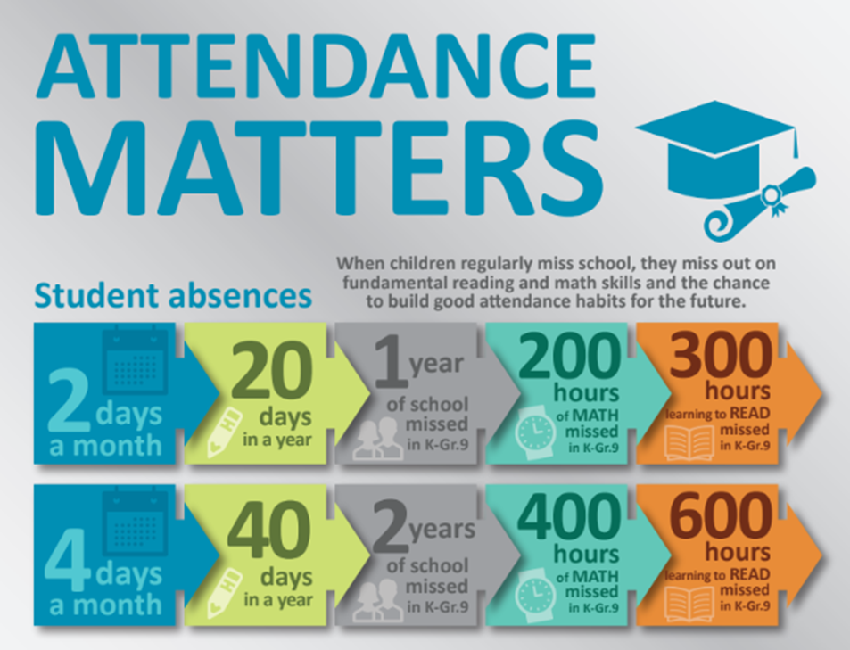

**Please refer to the** [**infographic**](https://drive.google.com/file/d/13tpw5bOoUVxnc2egjjKB0YaDsPU4iolZ/view?usp=sharing) **to see the relationship and why attendance is so important.**

**Attendance Guidelines**

1. Every day at school is a valuable learning experience. Students and their parents or guardians are reminded that absence from school is a serious matter and should be avoided if at all possible.
2. The school has legal responsibility to know the whereabouts of students during regular school hours. Whenever a student is absent from school or a particular class, parents or guardians are asked to phone the school at 306-296-2040 to report the absence. If there is prior knowledge that a student will be absent, a note may be sent. Parents or guardians will be contacted by phone on the days a student is absent for an unknown reason.

1. Whenever it is necessary for a student to be absent, she/he is responsible for all class work missed, regardless of the reason.

**Noon Hour**

1. Gr. 6-12 students are permitted to leave the school property at NOON HOUR 12:00-12:55 (Open Campus) and on spares at the parent’s discretion.
2. Kindergarten-Grade 5 students need written parent permission to leave the school property at any time during the school day.

**Check In/Check Out**

1. A student leaving the school FOR ANY REASON must come to the office and check out first.
2. Parents will be notified before a student is allowed to go home sick. If the parents cannot be notified, the student will stay in a safe location until the parent is able to be notified.

**Student Conduct**

[**AP 350**](https://docs.google.com/document/d/1V8rOh9jw_IS2hp4Kn27OkpL_OvqcdMqedoB2BTAXZGU/edit)

1. Students are to attend school regularly and punctually.
2. Students are to conform to the rules of the school as set out by the Principal.
3. Students are subject to discipline as would be exercised by a kind, firm, and judicious parent.
4. Students are to observe standards as set out in the rules of the school with respect to the rights of other persons.

**Every student is accountable:**

* To the teacher for their conduct on the school premises during school hours, and during such hours when the teacher is in charge of the student either in class, or out of the school while engaged in authorized school activities conducted during out-of-school hours. Principals may develop student contracts or develop other expectations ensuring that students are positive ambassadors for the school and are in good standing, recognizing that extracurricular activities are a privilege, not a right.
* To the Principal and members of the teaching staff at any time that they are under supervision of the school, including time spent traveling between the school and their place of residence.
* To the driver of a school bus, and to any other person appointed by the Division for the purposes of supervision during hours when students are in the personal charge of such employees, or persons appointed by the Division. Those appointed persons shall be responsible to, and report to the Principal. The [student conduct form](https://drive.google.com/file/d/1GtWSPssZOUu3SUn-qFdR3n0ySTl__A6Y/view) needs to be submitted to the school Principal.

In Frontier School it is expected that students’ actions, interactions and decisions reflect

* A drive for Excellence
* Compassionate dealings with others
* Respect of and for staff, students, the facility and guests
* A willingness to collaborate and cooperate with others
* A focus on attendance and participation

**At Frontier School** we strive to create the highest quality learning environment for our students. This ensures students are safe and cared for, and promotes the ability to have fun while learning.

We believe in the joint role of staff, parents/guardians and students to work to support students in assuming responsibility for their own actions, making choices that promote a growth mindset and a strong sense of accountability.

Student discipline is an important step in ensuring that we are creating opportunities for students to learn and develop from their mistakes. By adhering to expectations, we are supporting students in developing positive habits that will carry forward in their life outside of Frontier School and into their future.

It is imperative that students be held accountable for their actions so repeat offenses will result in escalating consequences.

**Frontier School Expectations and Non-Negotiables - Elementary Students (K-5):**

At Frontier School, we understand that elementary students are in the beginning stages of learning how to work together in a social setting, are establishing their understanding of norms and boundaries and are working on their emotional regulation in new and diverse situations. As such, their discipline ladder focusses on more immediate and shorter consequences that suit their development. Parents will be called at each step.

|  |  |
| --- | --- |
| **Minor Violations of School Conduct:** | **Major Violations of School Conduct:** |
| Step 1: loss of one recess  Step 2: loss of two recesses  Step 3: loss of three recesses including lunch  Step 4: half a day in the office  Step 5: full day in the office  Any additional steps will result in parents becoming involved. | Step 1: one week recess suspension  Step 2: one week recess suspension (may include out of school suspension)  Step 3: one week recess suspension + one day out of school suspension  Step 4: removal of recess until parents, teacher and admin can discuss a re-entry  plan  Step 5: removal of recess and out of school until a re-entry plan is established including parents, admin and the teacher in addition to other professional supports |

**Examples**

|  |  |
| --- | --- |
| **Minor Violations:** | **Major Violations:** |
| Repeated failure to meet classroom expectations  Disrespect to a teacher or other educator  Disruptive behaviour  Back talk  Inappropriate comments  Inappropriate touching  Questionable remarks (ie: lying) | Violence toward another person  Physical aggression or intimidation  *any act or behaviour which results in discomfort, embarrassment, pain or physical injury to another  *violence can be a deliberate act or it may be a result of negligent, thoughtless or reckless behaviour  *violent behaviour is considered differently than roughhousing |

**Frontier School Expectations and Non-Negotiables - Middle Years and High School Students (6-12):**

Frontier students will be encouraged to fix and learn from their mistakes and spend time reflecting on the reason for the behaviour and the choices being made. When a student chooses to not change or fix their mistake, and they have been sent to administration for follow-up, the following discipline ladder will be used. At all steps of the ladder, parents will be contacted.

|  |  |
| --- | --- |
| **Minor Violations of Student Conduct** | **Major Violations of Student Conduct** |
| Step 1: ½ day in-school suspension  Step 2: 1 day in-school suspension  Step 3: 2 day in-school suspension  Step 4: 1 day out of school suspension  Step 5: 2 day out of school suspension  Step 6: 3 day out of school suspension | Step 1: up to 3 days out of school suspension  Step 2: 3 day out of school suspension  Step 3: 5 day out of school suspension + parent meeting  Step 4: 7 day out of school suspension + parent meeting  Step 5: 10 day or expulsion + parent meeting |

**Examples**

|  |  |
| --- | --- |
| **Minor or below the line behaviours:** | **Major or bottom-line behaviours:** |
| Inappropriate comments/touching  Swearing/vulgarity/racist or sexist language Repeated failure to meet classroom expectations  Lates/skipping class in  Disruptive behaviour (interrupting learning)  Dress Code violations | Fighting/weapon/violence  Swearing at staff  Drugs/alcohol/illegal substance  Vandalism  Stealing  Inappropriate/sexual touching |

**These examples are not intended to be exhaustive but instead serve as exemplars.**

Behaviour will be evaluated in the three dimensions of Intensity, Durations, and Frequency and referred to school administration. Students will have consequences applied based on where they are on the discipline ladder. Behaviour with a significant combination of intensity, duration, and frequency will begin at a higher step.

**Gum and sunflower seeds are NOT permitted at school.**

**Energy Drinks are not allowed at the school**

**Substance Abuse**

It is unacceptable for any person to be under the influence of or in the possession of alcohol or other illegal drugs while at school and or involved in a school-sponsored activity. This includes as participants or spectators in school sponsored events. The school’s discipline policy will apply if students attend school or school sponsored events under the influence of alcohol or drugs or **suspected** of being under the influence of alcohol or drugs.

The use of tobacco or vaping products on the school property is illegal. We are a “Tobacco and Vape Free” facility. Using tobacco or vape products of any kind while on school property will result in consequences that may include suspension or legal action.

**Locks**

Frontier School requires that all Grade 6-12 students purchase locks for both their hallway locker as well as their gym locker. This is to teach student responsibility, and to ensure student belongings stay safe while not on the person. The lockers belong to the school and the Chinook SD and may be searched by school administration if it is warranted. If students lose or damage their lock, they are expected to replace it.

**Personal Technology - phones, wearables, etc.**

As per the new government of Saskatchewan regulations, “starting in the 2024-25 school year, phones will not be permitted during class time across K-12 schools in Saskatchewan.” Students are expected to either not bring their cellphones to school or store it in their locked locker during class time, during exams, pep rallies or any other time students are gathered.

Students who do not follow cell phone regulations will be referred to administration by the classroom teacher. Admin will remove cell phone from students' possession for the remainder of the day. Upon a third offense parents will be required to pick up the students cell phone from administration.

If a student refuses to surrender the cell phone to administration an automatic in-school suspension will be imposed.

If students continue to take their phones to class parents will be informed and further discipline will be implemented by administration.

We understand that cell phones are a convenient way to contact your child, however they pose a real interruption to classrooms. Students are distracted by the many notifications they receive daily. Our school has phones in every room. Please call the office if you need to leave a message for your child during school hours. We ensure they will get the message in a timely manner, and it gives us the opportunity to remind them of an important message later.

Regarding wearable technology, all watches that connect to a phone, headphones, etc. need to be turned to silent or do not disturb mode. Students are not permitted to use any devices in class.

**Dress Code**

School dress should reflect good taste, respect and professionalism. Keeping this in mind, the following guidelines should apply:

* Clothing should not be offensive to others (ie. containing racist, sexist or profane language or images, or references to drugs and/or alcohol)
* Clothings should not be revealing or allow for excessive skin exposure - torsos should be covered
* Students must remove wet or muddy footwear. Students should have other footwear available in this event.
* Physical education wear: students should wear a change of clothes to Physical Education class that allows comfortable freedom of movement required by all class activities, along with running shoes that have not been worn outside. All physical education dress should respectfully meet school dress code. Even when phys ed takes place outdoors students are required to change.

All dress code violations are to be reported to administration to adjudicate consistently.

Students deemed to be in contravention of the dress code may be asked to put on clothing supplied by the school, or be sent home to find more appropriate garments. Students may be sent home to get clean footwear. Parents may be contacted to assist with this issue. Repeated offenses may be dealt with under the discipline policies.

**Chromebook Policy - Middle Years and High School Students**

[**AP 140**](https://docs.google.com/document/d/1C25FvFk2n6bWe8fD8u5ZD_5xkQ1lwYEqABE8tTy6kmk/edit#heading=h.lsn1pt20s7r)

All students grade 6-12 will be assigned a Chinook owned chromebook for the entire year. This will be theirs to complete assignments within the school hours. Chinook owned Chromebooks will not be removed from the school grounds.

As per our cell phone policy, they will not have access to their phones in class to aid in research.

You are also welcome to purchase your own chromebook for use at school. The expectation is that you have it at school and fully charged at the start of every day.

You will be expected to pay a fee for lost or damaged chromebooks.

**Assignments and Home Expectations**

Students are expected to complete assignments on time. It is the students responsibility to communicate with their teacher if they are unable to meet deadlines. This means students may have to complete assignments on their own time as homework. Assignments never handed in may result in a zero.

Parents can help promote effective homework completion by providing a specific place and regular daily time and being available for support.

**Extended Student Absences**

When family trips occur on student contact days, students will be provided the assignments/homework/tests that they miss upon returning from their trip. It is expected that students complete these tasks on their own time, as homework, and hand in on the teacher-provided due date. Failure to complete these assignments may result in a zero.

**Academic Load and Spares**

Students are expected to carry a full load of 10 credits in grade 10.

At the minimum, students will enroll in and complete 9 credits in grade 11 and 8 credits in grade 12. Students have a spare in grade 11 or 12, they are welcome to stay at school and work constructively in a designated area or they can leave the school grounds during spares. All schedules and spare need to be approved by the school admin.

**Parent Communication**

All communication MUST be made through Chinook devices. This includes, but is not limited to: email, school phone number, seesaw app.

School Phone Number: 306-296-2040

All Teacher email address is *firstinitial lastname @chinooksd.ca* for example:

Lori Casat’s email address is: [Lcasat@chinooksd.ca](mailto:Lcasat@chinooksd.ca)

Some teachers also have “seesaw” and other apps to communicate

**Saskatchewan Graduation Requirements**

**for**

**Students Entering Grade 10 in 2024-2025**

* **24 credits are required for graduation in 2026-2027 school year**
* **ELA credits will change from 5 required credits to 3 required credits**
* ELA 10, ELA 20 and ELA 30 are the 3 ELA credits required
* Due to curriculums not being revised and updated in time for the 2024-25 school year, either an ELA 10A or ELA 10B will be offered. Both of them will meet the credit requirement of the ELA 10 credit.
* **Social Sciences will change from 3 required credits to 2 required credits**
* There will be 1 required Social Science credit at the Grade 10 level and 1 required Social Science credit at the 30 level.
* History, Social Studies and Native Studies 10 & 30 will meet the credit requirements until the curriculum has been revised.
* **Financial Literacy 10 will be a required course for graduation. The course will include some components of Career Education as well.** This course will be available for the second semester of 2024-2025 school year.
* **Math requirements remain the same. One credit must be attained at both the 10 level and 20 level.**
* **The Science requirements remain the same. One credit must be attained at both the 10 level and 20 level.**
* **There are no changes to the Physical Education (minimum 1 credit) or Practical & Applied Arts (minimum 2 credits) requirements.**

**NOTE**

These changes are based on provincial comparisons of ELA and Social Science credit requirements. Also, the provincial student council was an advocate for more flexibility allowing students to choose the electives they are interested in, thus reducing the number of required courses.

